**Task 01:**

**Activity_main.xml:**

*<?*xml version="1.0" encoding="utf-8"*?>*<LinearLayout xmlns:android="http://schemas.android.com/apk/res/android"  
 xmlns:app="http://schemas.android.com/apk/res-auto"  
 xmlns:tools="http://schemas.android.com/tools"  
 android:layout_width="match_parent"  
 android:layout_height="match_parent"  
 tools:context=".MainActivity"  
 android:weightSum="4"  
 android:orientation="vertical">  
  
 <TextView  
 android:layout_width="wrap_content"  
 android:layout_height="wrap_content"  
 android:text="@string/layout1"  
 android:textAppearance="?android:textAppearanceLarge"  
 android:background="@color/Yellow"  
 android:textStyle="bold"  
 android:layout_weight="2"/>  
 <TextView  
 android:layout_width="wrap_content"  
 android:layout_height="wrap_content"  
 android:text="@string/layout2"  
 android:textAppearance="?android:textAppearanceLarge"  
 android:background="@color/Blue"  
 android:textStyle="bold"  
 android:layout_weight="1"/>  
 <TextView  
  
 android:layout_width="wrap_content"  
 android:layout_height="wrap_content"  
 android:text="@string/layout3"  
 android:textAppearance="?android:textAppearanceLarge"  
 android:background="@color/Green"  
 android:textStyle="bold"  
 android:layout_weight="1"/>  
  
</LinearLayout>

**Output:**

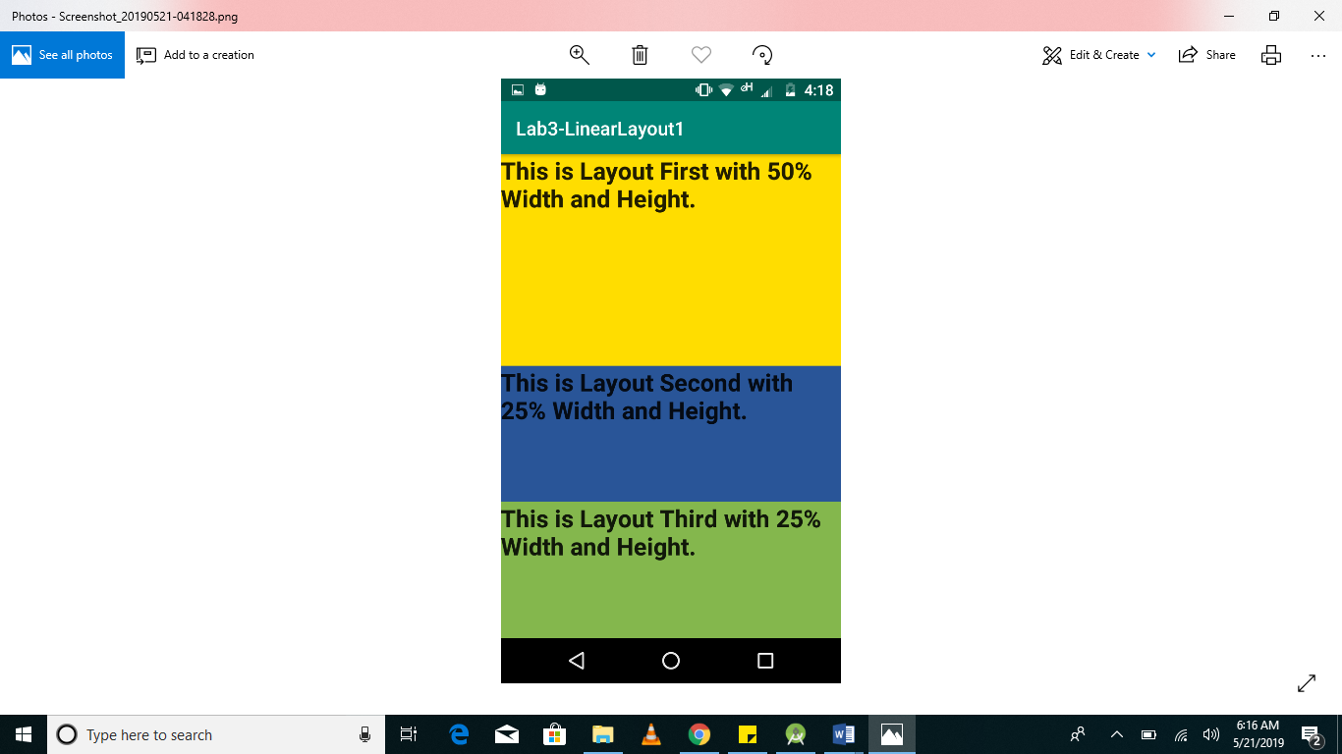

**Task 02:**

**Activity_main.xml:**

*<?*xml version="1.0" encoding="utf-8"*?>*<LinearLayout xmlns:android="http://schemas.android.com/apk/res/android"  
 xmlns:app="http://schemas.android.com/apk/res-auto"  
 xmlns:tools="http://schemas.android.com/tools"  
 android:layout_width="match_parent"  
 android:layout_height="match_parent"  
 android:orientation="vertical"  
 android:weightSum="5"  
 tools:context=".MainActivity">  
  
 <LinearLayout  
 android:layout_width="match_parent"  
 android:layout_height="match_parent"  
 android:orientation="horizontal"  
 android:weightSum="4"  
 android:layout_weight="1">  
  
 <TextView  
 android:id="@+id/result_TextView"  
 android:layout_width="wrap_content"  
 android:layout_height="100dp"  
 android:layout_weight="3.80"  
 android:text="0 "  
 android:textAlignment="textEnd"  
  
 android:textAppearance="?android:textAppearanceLarge"  
 android:textSize="50dp"  
 android:textStyle="bold" />  
  
 <Button  
 android:id="@+id/clear_button"  
 android:layout_width="wrap_content"  
 android:layout_height="match_parent"  
 android:layout_weight="1"  
 android:text=" C"  
 android:textSize="50dp"  
 android:textAlignment="textStart"/>  
 </LinearLayout>  
  
 <LinearLayout  
 android:layout_width="match_parent"  
 android:layout_height="match_parent"  
 android:orientation="horizontal"  
 android:layout_weight="1"  
 android:weightSum="4">  
  
 <Button  
 android:id="@+id/button7"  
 android:layout_width="wrap_content"  
 android:layout_height="match_parent"  
 android:layout_weight="1"  
 android:textSize="50dp"  
 android:text="7" />  
  
 <Button  
 android:id="@+id/button8"  
 android:layout_width="wrap_content"  
 android:layout_height="match_parent"  
 android:layout_weight="1"  
 android:textSize="50dp"  
 android:text="8" />  
  
 <Button  
 android:id="@+id/button9"  
 android:layout_width="wrap_content"  
 android:layout_height="match_parent"  
 android:layout_weight="1"  
 android:textSize="50dp"  
 android:text="9" />  
  
 <Button  
 android:id="@+id/add_button"  
 android:layout_width="wrap_content"  
 android:layout_height="match_parent"  
 android:layout_weight="1"  
 android:textSize="50dp"  
 android:text="+" />  
 </LinearLayout>  
  
 <LinearLayout  
 android:layout_width="match_parent"  
 android:layout_height="match_parent"  
 android:orientation="horizontal"  
 android:layout_weight="1"  
 android:weightSum="4">  
  
 <Button  
 android:id="@+id/button4"  
 android:layout_width="wrap_content"  
 android:layout_height="match_parent"  
 android:layout_weight="1"  
 android:textSize="50dp"  
 android:text="4" />  
  
 <Button  
 android:id="@+id/button5"  
 android:layout_width="wrap_content"  
 android:layout_height="match_parent"  
 android:layout_weight="1"  
 android:textSize="50dp"  
 android:text="5" />  
  
 <Button  
 android:id="@+id/button6"  
 android:layout_width="wrap_content"  
 android:layout_height="match_parent"  
 android:layout_weight="1"  
 android:textSize="50dp"  
 android:text="6" />  
  
 <Button  
 android:id="@+id/subtract_button"  
 android:layout_width="wrap_content"  
 android:layout_height="match_parent"  
 android:layout_weight="1"  
 android:textSize="50dp"  
 android:text="-" />  
 </LinearLayout>  
  
 <LinearLayout  
 android:layout_width="match_parent"  
 android:layout_height="match_parent"  
 android:orientation="horizontal"  
 android:layout_weight="1"  
 android:weightSum="4">  
  
 <Button  
 android:id="@+id/button1"  
 android:layout_width="wrap_content"  
 android:layout_height="match_parent"  
 android:textSize="50dp"  
 android:layout_weight="1"  
 android:text="1" />  
  
 <Button  
 android:id="@+id/button2"  
 android:layout_width="wrap_content"  
 android:layout_height="match_parent"  
 android:textSize="50dp"  
 android:layout_weight="1"  
 android:text="2" />  
  
 <Button  
 android:id="@+id/button3"  
 android:layout_width="wrap_content"  
 android:layout_height="match_parent"  
 android:textSize="50dp"  
 android:layout_weight="1"  
 android:text="3" />  
  
 <Button  
 android:id="@+id/multiply_button"  
 android:layout_width="wrap_content"  
 android:layout_height="match_parent"  
 android:textSize="50dp"  
 android:layout_weight="1"  
 android:text="*" />  
 </LinearLayout>  
  
 <LinearLayout  
 android:layout_width="match_parent"  
 android:layout_height="match_parent"  
 android:orientation="horizontal"  
 android:layout_weight="1"  
 android:weightSum="4">  
  
 <Button  
 android:id="@+id/dot_button"  
 android:layout_width="wrap_content"  
 android:layout_height="match_parent"  
 android:textSize="50dp"  
 android:layout_weight="1"  
 android:text="." />  
  
 <Button  
 android:id="@+id/button0"  
 android:layout_width="wrap_content"  
 android:layout_height="match_parent"  
 android:textSize="50dp"  
 android:layout_weight="1"  
 android:text="0" />  
  
 <Button  
 android:id="@+id/equal_button"  
 android:layout_width="wrap_content"  
 android:layout_height="match_parent"  
 android:textSize="50dp"  
 android:layout_weight="1"  
 android:text="=" />  
  
 <Button  
 android:id="@+id/divide_button"  
 android:layout_width="wrap_content"  
 android:layout_height="match_parent"  
 android:textSize="50dp"  
 android:layout_weight="1"  
 android:text="/" />  
  
  
 </LinearLayout>  
  
</LinearLayout>

**Output:**

